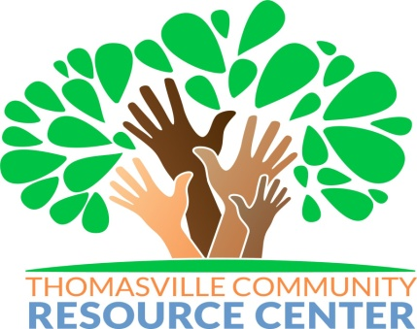

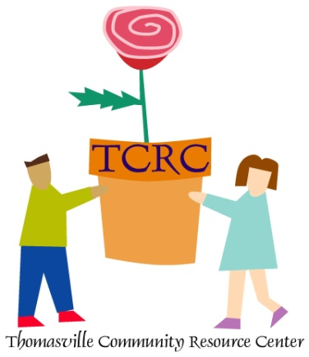
P.O. BOX 1897

THOMASVILLE, GEORGIA 31799-1897

Phone: (229) 226-5846 Fax: (229) 226-4595
Email: tcrc.receptionist@tcrc.community

Thomasville Community Resource Center

21st Century Community Learning Centers
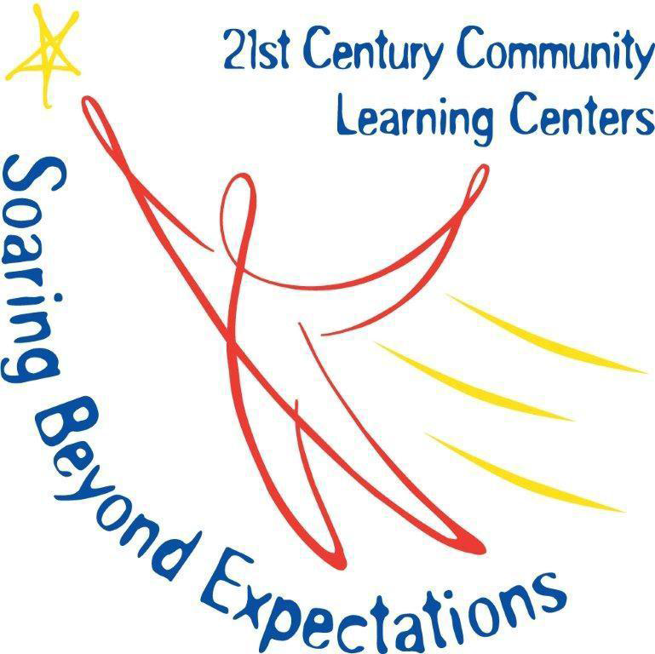

TCRC has had the great pleasure to operate as a 21st Century Community Learning Center (21st CCLC) provider since 2008. External contractors evaluate all 21st CCLC program sites. Qualitative and quantitative data is collected to measure program impact at all sites. The primary focus of the outcome evaluation is the examination of the extent to which the 21st CCLC achieved the project objectives. This opportunity has allowed the organization to expand its after school program with the over-arching goal of improving academic achievement, behavior, and increasing parental involvement. The sites are grant funded with TCRC as a “sub-recipient” to the Georgia Department of Education. This year over 200 children from Pre K – 5th grade are served at the 3 school-based 21st CCLC locations. Certified teachers and para-professionals provide academics and homework help. Project based learning activities are provided based on Science, Technology, Engineering, Arts, and Math (STEAM). The TCRC 21st CCLC sites include:
- Harper Elementary Thomasville
- Scott Elementary Thomasville
- Pelham Elementary Mitchell County

YOUTH DEVELOPMENT / ENRICHMENT & FAMILY ENGAGEMENT SUB-CONTRACTS
Completion and submission of a TCRC 21st CCLC enrichment contract application constitutes acceptance of all TCRC policies and procedures as well as 21st CCLC program guidelines. Subcontractors agree to abide by the results of the selection process. Contractor selection is based on the community need and available funding.

ELIGIBLE SUB-CONTRACT APPLICANTS
Eligible applicants may include individuals, faith based organizations, institutions of higher education, city or county government agencies, for-profit corporations and other public or private entities. Successful applicants must demonstrate experience in providing educational and related activities that will complement and enhance the academic performance, achievement and positive youth development of students.

GRANT ASSURANCES
Completion and submission of a TCRC 21st CCLC enrichment contract application constitutes acceptance of all identified assurances, agreements, and guidelines of TCRC and the GA-DOE 21st CCLC program. Contractors agree to abide by the results of the selection process.

COMPETITIVE PRIORITY
All applications will be assessed competitively according to the scoring rubric criteria. Priority will be afforded to those providers with experience working with Elementary school students.

DUE DATE AND TECHNICAL ASSISSTANCE
All proposals must be emailed to tcrc.receptionist@tcrc.community
All questions must be submitted to tcrc.receptionist@tcrc.community.
PROPOSAL QUESTIONS
- Organization / Individual address, city/state, zip code, county, phone number and email. (5 points)

- Provide a summary of your experience working with youth in athletic, dramatic, character development, health or STEAM related enrichment programs. Be specific when outlining activities and tasks working directly with youth and explain how these activities benefit youth development (Two pages or less). (35 points)
  - Youth is defined as students from age 4 – 15
  - Athletic/Sports Enrichment: Including but not limited to Football, Basketball, Tennis, Golf, Track and Field. Multiple day event with giveaways and character development for students
  - Health: Including but not limited to Physical Fitness Activities, Food and Nutrition
  - STEAM: Science Technology, Engineering, Arts (Visual and Performing), and Math

- Provide a brief summary of credentials, certifications or training you have received in the specific enrichment areas you are submitting in your proposal (One page or less). (15 points)

- Are you currently providing services to Pre K – 8th Grade youth? (Yes 10 points)

- Have you currently or within the last 3 years provided services to Elementary School students (Yes 10 points)

- Have you currently or within the last 3 years provided services to at risk youth (Yes 10 points)

- Provide 2 references: Organization name, Point of contact Email and/or Phone number for organizations you have provided enrichment services in the past 3 years.

Requested Amount (include the hourly rate for your services) to be paid for services $___________

Please review the information on the 21st Century Community Learning Center Program and the current sites operated by Thomasville Community Resource Center included with this solicitation.

Contractor work and payout schedule will be included in contract after proposal review and selection. 21st CCLC sites typically operate M-F afterschool during the school term (excluding breaks and holidays). Summer program sessions typically operate M-TH with times to be determined based on availability of funds.

A Certificate of Insurance is required for all Athletic, Dance, and Physical Fitness Enrichment Activities.

All contractor staff working with students must pass a Comprehensive Background Screen and Drug Test. TCRC will pay for the Background check and drug test.

All documents will be posted at http://www.tcrconline.org/employment.aspx . Technical Assistance responses will also be posted on the site

